UX-Research

Evers,Koen K.

2021-2022

Inhoudsopgave

**Research purpose** 2

**Research methods** 2

**Designs** 2

Design 1 2

Design 2 3

**Research** 4

Setup 4

Results 4

Survey 1 4

Survey 2 5

**Conclusion** 5

# **Research purpose**

To analyse and gather feedback on possible designs for the order status page.

# **Research methods**

This research was done following the DOT framework. The following methods were used:

* Survey

# **Context**

This is the UX research for the order status page that could be implemented in the Mediaan group project. The order status page is not within scope at this time. This page would show once customers have ordered items and are awaiting the delivery of ordered items.

# **Designs**

## Design 1

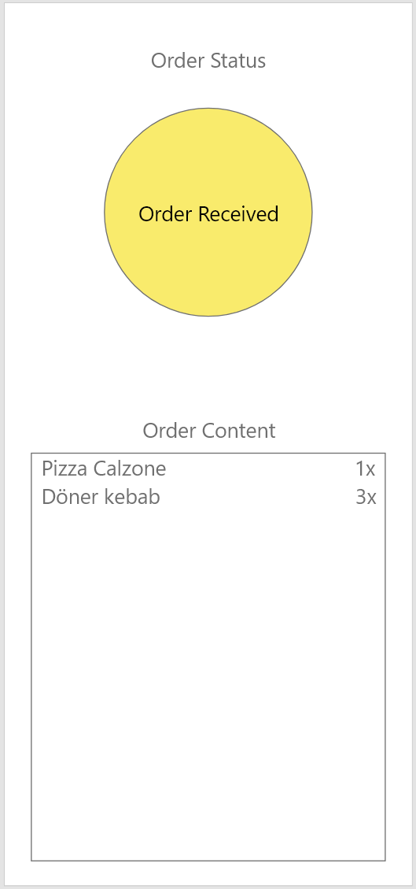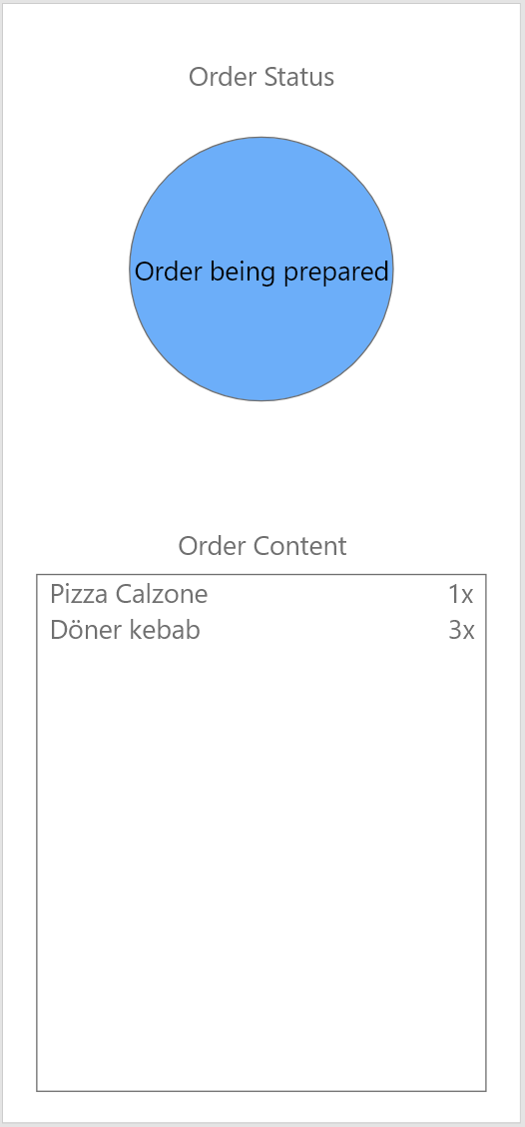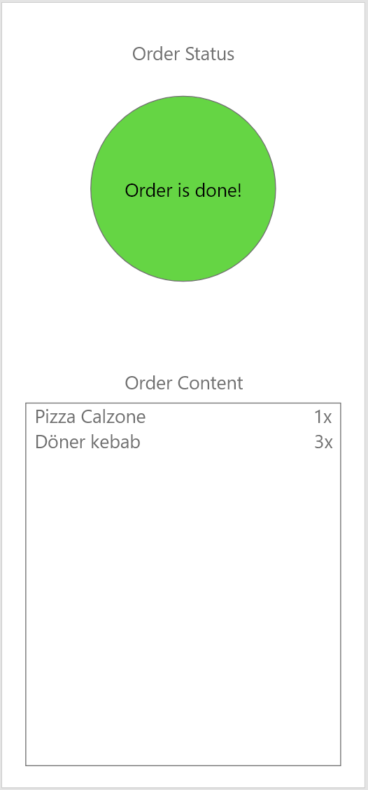

In design 1 the customer would see this page upon ordering. The circle underneath Order Status would change colour and text based on the status of their order.

## Design 2

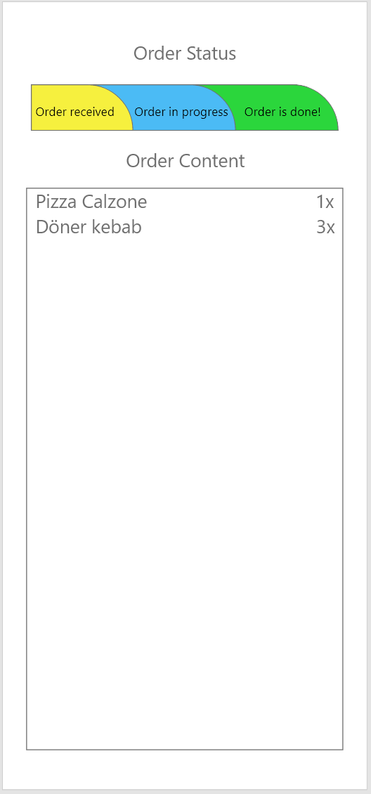

In design 2 the customer would see this page upon ordering. The horizontal bar underneath Order Status would fill in based upon the status of the order. (yellow for order received, fill the blue bar when order is in progress, fill the green bar when the order is ready)

# **Research**

## Setup

I have given out 2 surveys in which the two different designs were visible.  
The first survey had the questions: “Which design do you prefer?”. “What would you change to the preferred design?”  
The second survey was taken in person and went as follows: a design would be shown to a person for 5 seconds. After which they were asked to provide a score from 1 to 10 with 10 being the highest score. This would be done for both designs.

## Results

### Survey 1

5 people answered.

**Which design do you prefer?**

60% preferred Design 1,   
40% preferred Design 2.

**What would you change to the preferred design?**

Design 1  
“Have a rotating effect to show that the page hasn’t crashed.”  
“Nothing.”  
“Clean up the colours and add total price to order content.”

Design 2  
“Reorganise the layout, order content takes up too much space”  
“Add cost to order content”

Survey 1 shows that people preferred design 1 but would like to see an effect and total price.

### Survey 2

This survey was given out to 4 different people.

**Design 1**

Person 1 was shown design 1 for 5 seconds and asked to rate it from 1 to 10.  
The score given was a 7.

Person 2 was shown design 1 for 5 seconds and asked to rate it from 1 to 10.  
The score given was a 5.

Person 3 was shown design 1 for 5 seconds and asked to rate it from 1 to 10.  
The score given was a 6.5.

Person 4 was shown design 1 for 5 seconds and asked to rate it from 1 to 10.  
The score given was a 8.

Average score for design 1 was a 6.625

**Design 2**

Person 1 was shown design 2 for 5 seconds and asked to rate it from 1 to 10.  
The score given was a 5.

Person 2 was shown design 2 for 5 seconds and asked to rate it from 1 to 10.  
The score given was a 6.

Person 3 was shown design 2 for 5 seconds and asked to rate it from 1 to 10.  
The score given was a 5.5.

Person 4 was shown design 2 for 5 seconds and asked to rate it from 1 to 10.  
The score given was a 5.

Average score for design 2 was 5.375

Survey 2 shows that design 1 was preferred but not very highly rated.

# **Conclusion**

The surveys show that design 1 was preferred but could still improve.  
Improvements made to the design could include:

* An effect to show the page still working.
* Cost added to the order contents
* Cleanup of the used colours.